Lab 15: Iteration

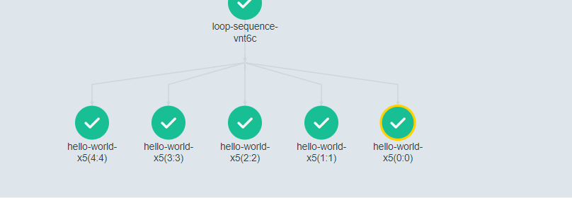

apiVersion: argoproj.io/v1alpha1

kind: Workflow

metadata:

  generateName: loop-sequence-

  namespace: argo

spec:

  entrypoint: loop-sequence-example

  serviceAccountName: training

  templates:

  - name: loop-sequence-example

    steps:

    - - name: hello-world-x5

        template: hello-world

        withSequence:

          count: "5"

  - name: hello-world

    container:

      image: docker/whalesay:latest

      command: [cowsay]

      args: ["hello world!"]

For items UI

apiVersion: argoproj.io/v1alpha1

kind: Workflow

metadata:

generateName: loops-

namespace: argo

spec:

entrypoint: loop-example

serviceAccountName: training

templates:

- name: loop-example

steps:

- - name: print-message

template: whalesay

arguments:

parameters:

- name: message

value: "{{item}}"

withItems: # invoke whalesay once for each item in parallel

- hello world # item 1

- goodbye world # item 2

- name: whalesay

inputs:

parameters:

- name: message

container:

image: docker/whalesay:latest

command: [cowsay]

args: ["{{inputs.parameters.message}}"]

withItems more complex example

apiVersion: argoproj.io/v1alpha1

kind: Workflow

metadata:

  generateName: loops-maps-

  namespace: argo

spec:

  entrypoint: loop-map-example

  serviceAccountName: training

  templates:

  - name: loop-map-example # parameter specifies the list to iterate over

    steps:

    - - name: test-linux

        template: cat-os-release

        arguments:

          parameters:

          - name: image

            value: "{{item.image}}"

          - name: tag

            value: "{{item.tag}}"

        withItems:

        - { image: 'debian', tag: '9.1' }       #item set 1

        - { image: 'debian', tag: '8.9' }       #item set 2

        - { image: 'alpine', tag: '3.6' }       #item set 3

        - { image: 'ubuntu', tag: '17.10' }     #item set 4

  - name: cat-os-release

    inputs:

      parameters:

      - name: image

      - name: tag

    container:

      image: "{{inputs.parameters.image}}:{{inputs.parameters.tag}}"

      command: [cat]

      args: [/etc/os-release]